Amazon Route 53

Class No:29

Amazon Route 53

Amazon Route 53 is a highly available and scalable cloud Domain Name System (DNS) web service. It’s designed to give developers and businesses an extremely reliable and cost-effective way to route end users to internet applications by translating names like example.com into the numeric IP addresses like 192.0.2.1 that computers use to connect to each other.
The name "53" is a reference to TCP/UDP Port 53, which is the standard port for DNS queries.

Core components

- Authoritative DNS: Route 53 is an authoritative DNS service, meaning it holds the actual DNS records for a domain.
- Global Service: It is a global service (like IAM or CloudFront), meaning it is not tied to a specific AWS Region.
- Health Checks: It can monitor the health and performance of your application endpoints (web servers, S3 buckets, etc.).
- DNS Resolver: It can answer recursive DNS queries for both public and private (VPC) resources.
- Domain Registration: You can purchase and manage domain names (e.g., .com, .net, .org) directly through the AWS Console.
- Alias Records: A unique AWS feature that allows you to point your zone apex (the "naked" domain like example.com) to AWS resources like Load Balancers or CloudFront distributions.

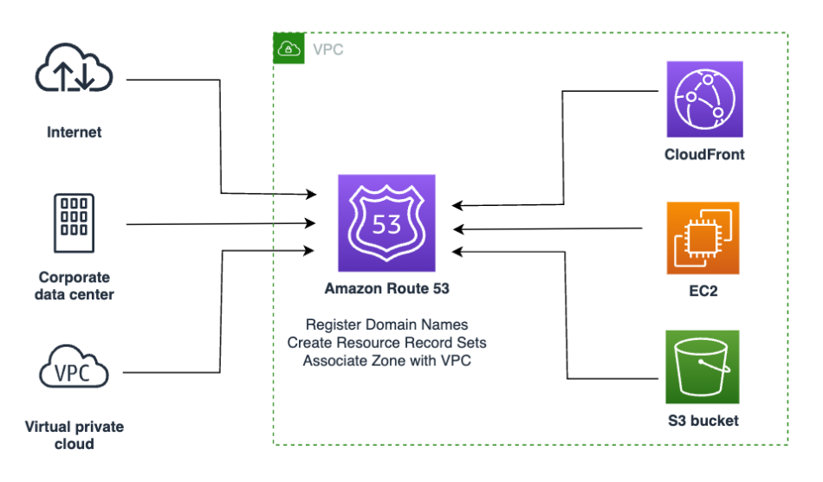

Route 53 Routing Policies
Routing policies determine how Route 53 responds to DNS queries. You can choose a policy based on your application's architecture and performance needs.
1. Simple Routing
- Explanation: Maps a domain to a single resource. You can specify multiple IP addresses in one record, and Route 53 will return all of them to the user in a random order.
- Purpose: Use for basic web applications with a single server or a single load balancer.
- Note: It does not support health checks.

2. Weighted Routing
- Explanation: Allows you to assign "weights" (0-255) to multiple resources. Traffic is distributed based on the proportion of the weight.
- Purpose: Ideal for A/B testing, canary releases, or gradually migrating traffic from an old stack to a new one.
- Example: 80% of traffic to "Version A" and 20% to "Version B."

3. Latency-Based Routing
- Explanation: Routes users to the AWS Region that provides the lowest network latency (fastest response time) for that specific user.
- Purpose: Improving user experience for global applications by serving them from the nearest geographic region.
- Example: A user in Tokyo is routed to ap-northeast-1, while a user in London goes to eu-west-2.

4. Failover Routing (Active-Passive)
- Explanation: Uses health checks to monitor a primary resource. If the primary becomes unhealthy, Route 53 automatically starts routing traffic to a secondary "DR" (Disaster Recovery) resource.
- Purpose: Creating High Availability and disaster recovery setups.
- Example: Primary is an ALB in us-east-1; secondary is a static "Site Under Maintenance" page in S3.

5. Geolocation Routing
- Explanation: Routes traffic based on the geographic location of your users (continent, country, or even state in the US).
- Purpose: Localizing content (different languages), restricting distribution to specific countries for licensing, or balancing load across regional endpoints.
- Note: This is based on location, not necessarily speed (unlike Latency routing).

6. Geoproximity Routing (Traffic Flow)
- Explanation: Routes traffic based on the physical distance between your users and your resources. You can apply a "Bias" to expand or shrink the size of a geographic region being served by a resource.
- Purpose: Complex global traffic management where you want to shift traffic from one region to another manually.
- Note: Requires using Route 53 Traffic Flow (a visual editor).

7. Multi-Value Answer Routing
- Explanation: Similar to simple routing but allows you to return up to eight healthy records in response to a DNS query.
- Purpose: Provides a basic "DNS-level" load balancing.
- Benefit: Unlike Simple Routing, it supports health checks, so it only returns IPs for healthy instances.

8. IP-Based Routing
- Explanation: Routes traffic based on the user's specific IP address range (CIDR blocks).
- Purpose: Highly granular control. For example, routing traffic from a specific corporate network to a private internal endpoint or providing "Premium" users with dedicated high-performance servers based on their known IP range.

Hands on: Route53

Consider we have purchased a domain name in godaddy ( a dns provider).
Now we are going to use route53 to map the ip address (endpoint) of our Ec2 with the domain name.

Step no:1 Go to go daddy and create a domain name: nithya.com

Step no:2 Now go to AWS Route53 Create hosted zone.
Name: nithya.com
Type: Public hosted zone

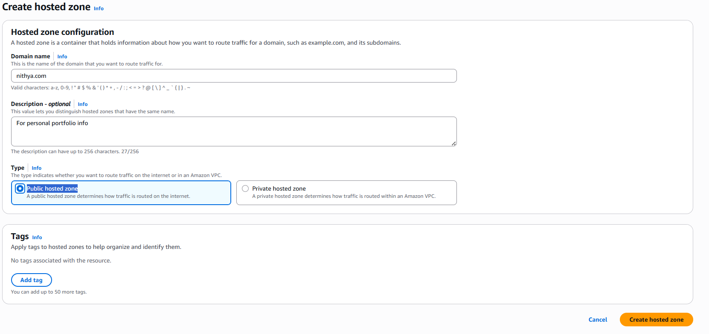

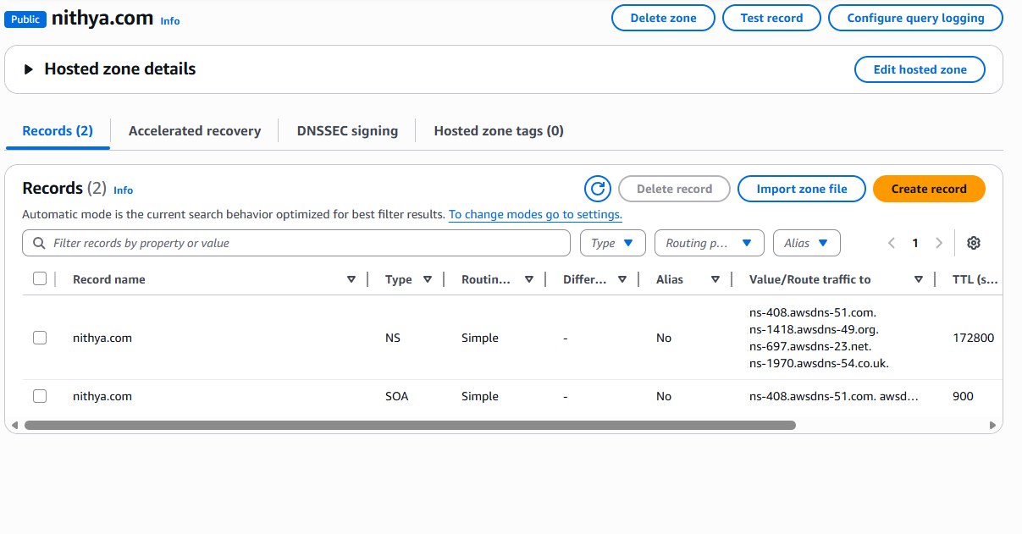
As we can see a list of name servers we will exchange it with the godaddy to establish the connection between them.
Here we have not made any purchase of domain name, assume that we have purchased nithya.com.

Step no:2 Now we should have an endpoint to make use of the domain name that we have added in the route 53.
Go to Ec2 console create a Linux instance Copy the public Ip address of the instance.

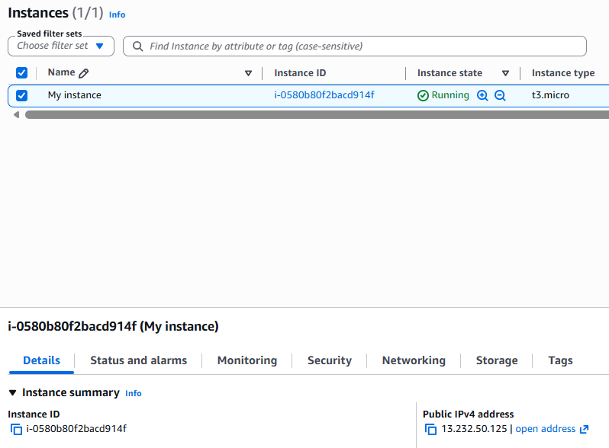

Step no:3 Now we have to create a record in the route 53 to make use of the domain name and the endpoint of the
Ec2(public ip).

Click Create record No sub domain provide the public ip of the Ec2 instance in the value Type of routing as Simple routing.

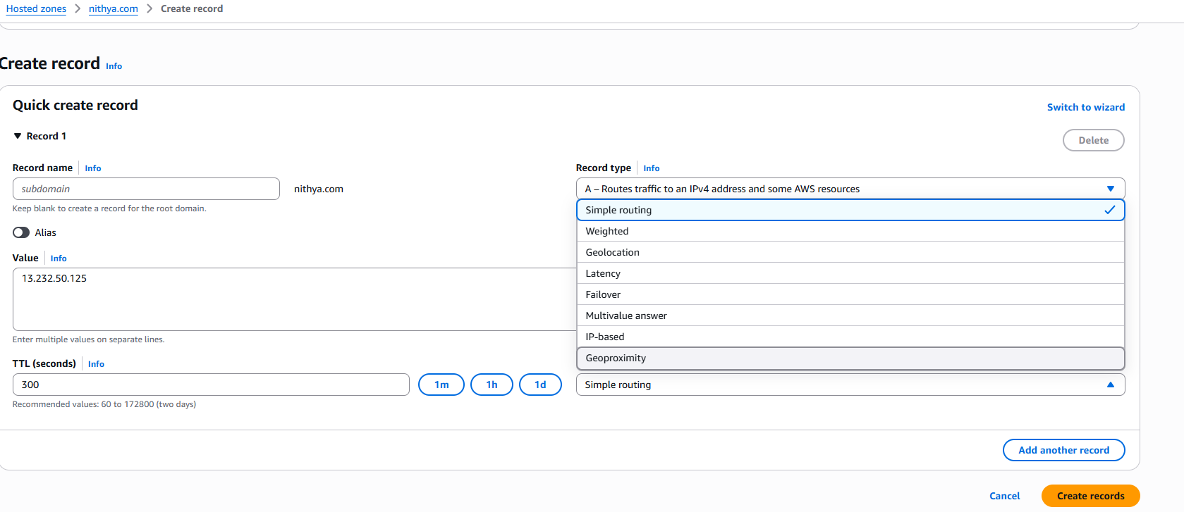

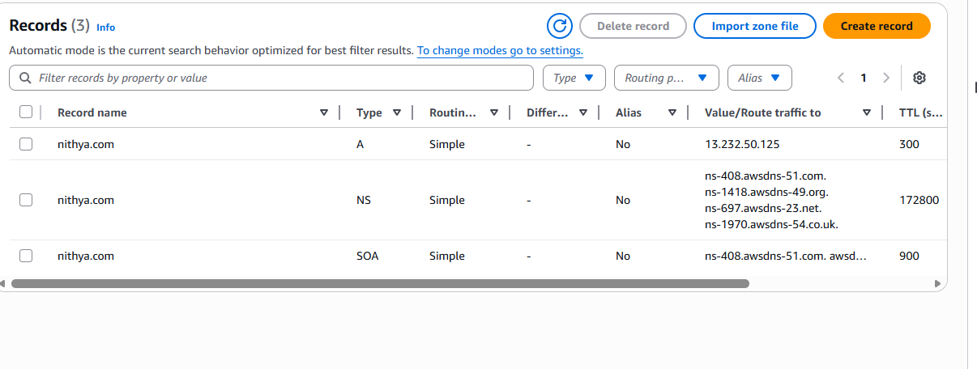

Step no:4 consider we want to map the domain name with an load balancer, there will be multiple of them, to connect
precisely we have an option in the record called Alias.

This helps us to connect with the specific endpoints of a resource clearly.
Create an application load balancer.
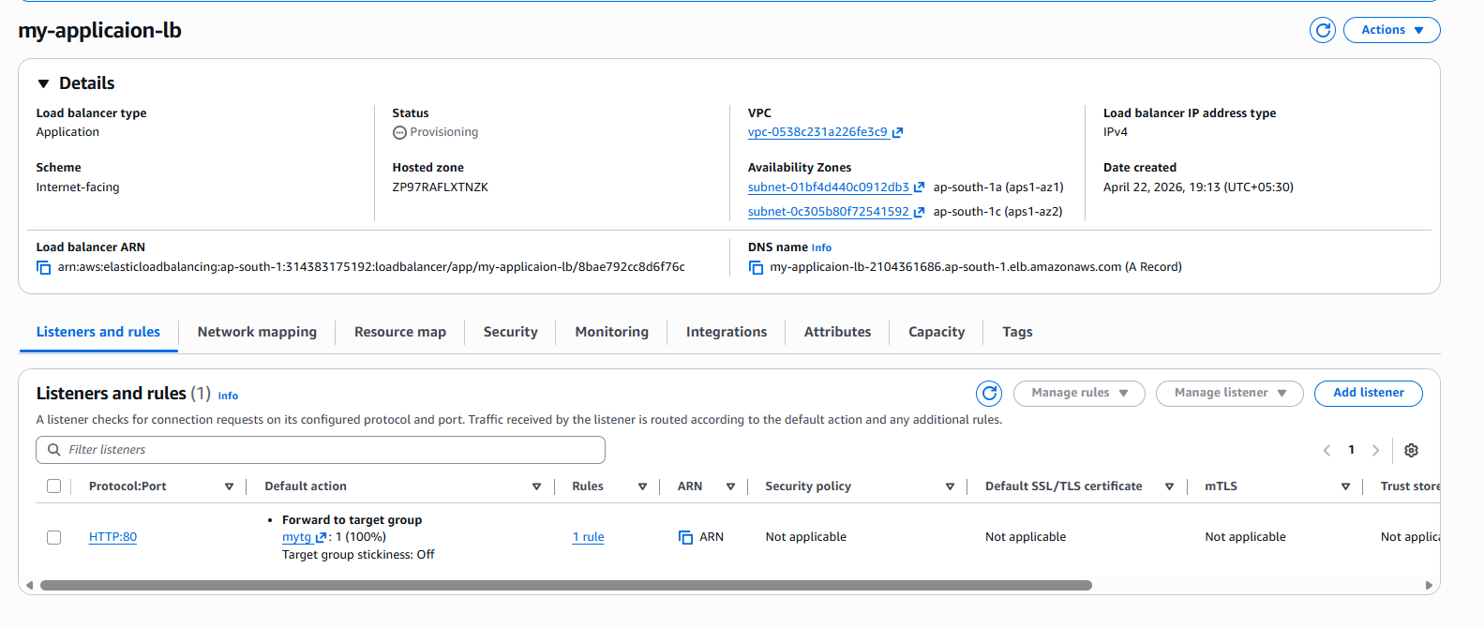

Then come to Route 53 Our hosted zone: nithya.com create record
Enable Alias Choose Application and Classic Load balancer .
It will ask for region. Our AL is in Asia pacific region. Choose that , it will list the available ALB there.
We can see my-application-lb which we have created Choose it and respective routing create record.

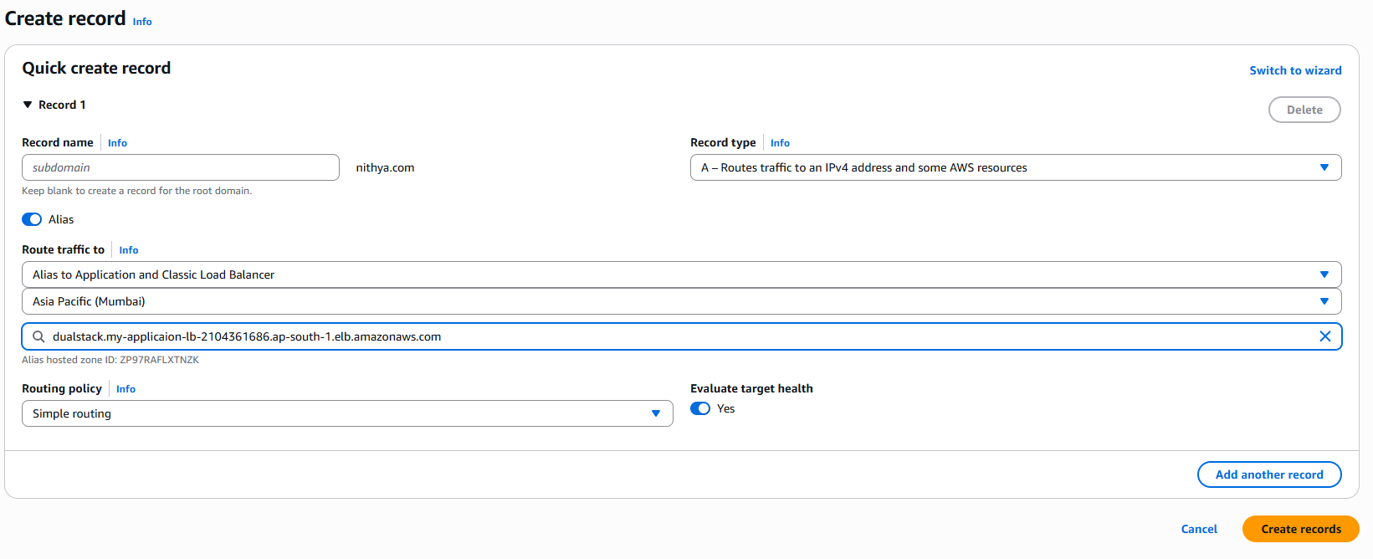
Note: You must delete the existing record in order to create a new one on the same hosted zone.
Also, we can use S3 buckets end points, NLB, etc.,
The Route 53 is a global service, hence we can route Dns for resources from any region, AZs also.
Once the record has been created if we type the Domain name in browser it will show the contents in the respective
endpoints resource. For example, if we have ip address of an Ec2 instance mapped with the domain name using the
route 53, the application or website contents in the Ec2 will be displayed if we enter the Domain name.

